**Assessing Economic Impact of Flooding in Lodi, NJ**

Ivan De la Paz and Karina Magro Machado

Department of Earth and Environmental Studies, Montclair State University

EAES575 – Environmental Economics

Dr. Pankaj Lal

December 13th, 2024

**1. Introduction and Background**

**1.1. Objective**

Flooding is one of the most common natural disasters, posing substantial environmental, economic, and social issues worldwide. Urban areas are especially vulnerable because impermeable surfaces like asphalt and concrete exacerbate stormwater runoff, resulting in frequent and severe flood events. Addressing these difficulties necessitates novel solutions that strike a balance between environmental sustainability and economic profitability.

The major goal of this research is to investigate the economic implications of flooding in Lodi, New Jersey, as well as the viability of using permeable pavement as a long-term flood prevention approach. The study aims to investigate community opinions of flooding severity and satisfaction with present mitigation initiatives. It also seeks to better understand people's willingness to invest in long-term solutions such as permeable pavement, as well as their preferred funding channels. Finally, the report makes concrete recommendations for creating effective and fair flood resilience strategies customized to Lodi's specific demographic and economic situation.

**1.2. Study Area Description**

Lodi, a small but historically rich town in Bergen County, New Jersey, is a culturally and historically significant community. Lodi's history dates back to the early 1700s, when European settlers arrived. The area was predominantly agricultural, with farmlands dominating the scenery. Its name is thought to be derived from the Italian city of Lodi in Lombardy, indicating the impact of Italian immigrants who arrived in the area in the late nineteenth and early twentieth century (Lodi Memorial Library, n.d.).

The town was officially constituted as a borough in 1894, amid Bergen County's "boroughitis" epidemic, which saw hundreds of minor towns become boroughs. Lodi grew from an agricultural hub to a more urbanized community throughout the years, helped by its closeness to big cities like Paterson and New York City. Industrial growth in the twentieth century created manufacturing jobs and economic prospects, attracting a wide range of immigrants, including Italians, Eastern Europeans, and subsequently Latin Americans. Today, Lodi is a thriving community noted for its diverse cultural offerings, small businesses, and accessibility to major urban areas (Lodi Memorial Library, n.d.).

Lodi is now predicted to have a population of 25,832 by 2023 (U.S. Census Bureau, 2023). The community's demographics are diverse, with the largest ethnic groups being White (Non-Hispanic) at 39.4%, Hispanic or Latino at 40.5%, Two or More Races at 19.7%, and Black or African American at 9.6%. The median family income is $84.570, indicating recent economic improvement (U.S. Census Bureau, 2023), and the population's median age is 38.7 years (Data USA, n.d).

**1.3 Lodi’s Flooding History**

Historically, the Saddle River was a key factor in Lodi's agricultural success, providing essential water resources that sustained the borough's early farming economy. However, over time, this natural advantage has transformed into a significant challenge. Lodi’s proximity to the Saddle River places parts of the borough within a floodplain, making it particularly vulnerable to flooding.

**Figure 1**

*Study Area - Flooding Zones*

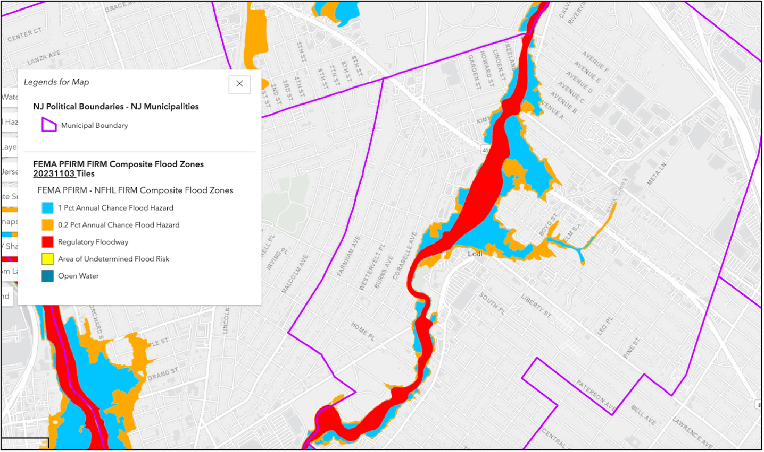

Note. Map of Lodi, NJ, highlighting FEMA-designated flood zones, including high-risk areas (red: regulatory floodway) and moderate to low-risk areas (blue and orange), demonstrating the town's vulnerability to flooding along the Saddle River.

The Saddle River, located in northeastern New Jersey within the Piedmont physiographic province, has a drainage area ranging from 54.6 square miles in Lodi to 59.8 square miles downstream. Originating in Rockland County, New York, the river flows southward into Bergen County, New Jersey, where Stink Creek joins it as it passes through Lodi. Eventually, the Saddle River empties into the Passaic River, just 1.1 miles downstream from Lodi.

The basin’s landscape is relatively mountainous, with the study reach measuring approximately 2.75 miles, an average channel width of 109 feet, and a slope of 8.5 feet per mile. According to the New Jersey Department of Environmental Protection (2010), the surrounding land use is predominantly urban or developed (81.2%), with smaller portions of woodland (11.2%) and cropland (0.5%). The area’s continued urban development, coupled with population growth from 23,971 in 2000 to 24,136 in 2010 (US Census Bureau, 2012), has intensified flood risks. Additionally, six significant road crossings intersect the river’s main channel and floodplain (Hoppe & Watson, 2012).

**1.3.2 Flooding in Lodi (2014–2024)**

Between 2019 and 2024, Lodi experienced a dramatic increase in flooding events, further emphasizing the town’s vulnerability and the urgent need for long-term mitigation strategies. Over this five-year period, Lodi faced 17 flooding episodes, including five major floods, three moderate floods, and nine minor floods. In stark contrast, the previous five-year period (2014–2019) recorded only two major flood events. This represents more than a doubling of major floods, underscoring the growing risks to the borough as climate change intensifies weather patterns and urban development places additional strain on the area’s stormwater infrastructure (Survey, 2023).

The recent increase in major flood events has had severe impacts on the community. In January 2024, the Saddle River crested twice within the same month, reaching major flood stages of 10.1 feet and 10.2 feet, causing extensive damage to homes and streets. In March 2024, a moderate flood with a gage height of 7.1 feet again highlighted the borough’s ongoing challenges with stormwater management. One of the most severe floods during this period occurred in August 2021, when remnants of Hurricane Ida brought a major flood, with a gage height of 12.2 feet, overflowing by a staggering 6.7 feet. Major events such as Hurricane Irene in 2011 and the January 2024 floods, during which the Saddle River crested and inundated residential neighborhoods, underscore this susceptibility. These events caused significant property damage, forced evacuations, and highlighted the town's reliance on impermeable surfaces, which exacerbate stormwater runoff and flood risks (Taitt, 2024).

**Figure 2**

*Flooding data 2014-2024*

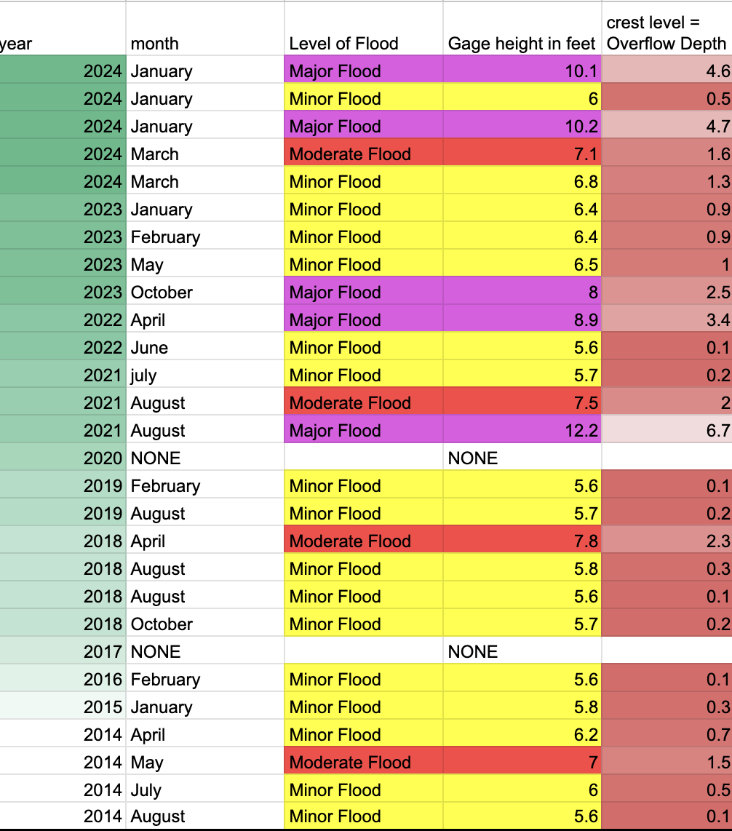*Note.* This image shows the flood data from Lodi NJ. Every year from 2014 to 2024 broken down by month, flood level, Gage height in feet, and Crest level

This uptick in severe flooding illustrates the borough’s increasing exposure to extreme weather events. Compared to 2014–2019, where floods were generally less frequent and severe, the more recent period demonstrates a troubling trend. The higher number of major floods, combined with persistent moderate and minor floods, has stretched local resources, leading to repeated cycles of emergency response and long-term recovery efforts. Lodi officials have acknowledged the need for comprehensive flood management solutions to address this escalating crisis. Efforts include improving stormwater infrastructure, exploring natural flood mitigation methods, and advocating for federal and state funding to support resilience-building initiatives (Taitt, 2024).

**2. Literature Review**

**2.1 Flood Mitigation Performance of Permeable Pavements in Urbanized Catchments (Arora et al., 2023)**

Arora et al. (2023) conducted a case study examining the role of permeable pavements (PP) in mitigating urban flooding within the Elizabeth Street Catchment in Melbourne, Australia. This research analyzed the integration of PP systems into urban landscapes, focusing on their ability to reduce peak stormwater flows and overall runoff volumes. The study found that permeable pavements reduced peak flows by 7–16% during storm events of varying intensity. Importantly, the research highlighted that the flood mitigation benefits of PP systems are influenced by maintenance practices; without proper upkeep, clogging can significantly reduce the pavements' performance. The study employed hydrological modeling to simulate rainfall and land-use scenarios, offering actionable data to assist urban planners and local governments in implementing water-sensitive urban design (WSUD) strategies. This research informs our study by providing evidence of PP systems' efficacy in managing urban stormwater, a critical issue for flood-prone regions like Lodi, NJ, and underscores the importance of considering maintenance requirements when proposing PP solutions.

**2.2 Permeable Pavement Systems for Effective Management of Stormwater Quantity and Quality: A Bibliometric Analysis (Singer et al., 2022)**

Singer et al. (2022) conducted a bibliometric analysis and systematic review of permeable pavement systems (PPS) to explore their evolution, research trends, and practical applications in managing stormwater. The study identified PPS as a cornerstone of sustainable urban drainage systems (SUDS), demonstrating their ability to mitigate runoff volume, improve water quality, and reduce urban flooding risks. Innovations in PPS, such as incorporating recycled aggregates and optimizing structural designs, were found to enhance their efficiency. However, challenges such as high initial costs, maintenance difficulties, and susceptibility to clogging were noted as barriers to widespread adoption. This study also highlighted the importance of combining PPS with complementary infrastructure like retention basins and green roofs to maximize their effectiveness. For our research, this work emphasizes the growing body of evidence supporting PPS as a sustainable flood mitigation strategy while identifying gaps in public understanding and technical implementation, which our study seeks to address through community-based willingness-to-pay initiatives.

**2.3 Willingness to Pay for Flood Insurance (Netusil et al., 2021)**

Netusil et al. (2021) examined willingness-to-pay (WTP) for flood insurance in the United States, particularly focusing on low- and middle-income households in flood-prone areas. The study revealed that WTP is influenced by factors such as perceived flood risk, household income, and prior flood experiences. Residents in 100-year floodplains expressed a WTP of 47–59% of the median flood insurance premium, suggesting financial barriers to securing coverage. The findings highlighted a critical gap between flood insurance demand and affordability, especially for vulnerable populations. This study's focus on eliciting WTP through surveys aligns with our research methodology, providing a framework for understanding community attitudes toward flood resilience measures. By drawing parallels between flood insurance and permeable pavement solutions, our study fills a research gap by evaluating public investment preferences in sustainable infrastructure, expanding the discussion on equitable flood mitigation strategies.

**2.4 Assessing the Performance of Permeable Pavement in Mitigating Flooding in Urban Areas (Lee et al., 2023)**

Lee et al. (2023) investigated the long-term flood mitigation benefits of permeable pavements through a demonstration project in Taoyuan City, Taiwan. By constructing test roads with both permeable and conventional pavements, the study monitored runoff data during various rainfall events. Results showed that permeable pavements reduced peak discharge by 60–75% and delayed runoff, significantly alleviating stress on urban drainage systems. The study also highlighted the potential of permeable pavements to improve water retention for reuse in agriculture, showcasing their versatility as a low-impact development (LID) strategy. Lee et al. stressed the importance of integrating monitoring systems and innovative construction techniques to optimize the performance of permeable pavements. This study is particularly relevant to our research as it provides empirical evidence supporting the installation of permeable pavements as a means of reducing flood risks in urbanized, flood-prone regions like Lodi, NJ. Furthermore, the focus on practical implementation aligns with our aim to assess community acceptance and funding mechanisms for such projects.

**2.5 Synthesis and Contribution to Research Gap**

The above studies collectively highlight the potential of permeable pavements as a sustainable solution for managing urban flooding while emphasizing challenges such as maintenance, public acceptance, and financial constraints. our research builds on these findings by focusing on a specific community's willingness to pay for permeable pavement projects, thus addressing gaps in understanding public attitudes toward flood mitigation infrastructure. By integrating insights from these studies, our work not only evaluates the technical feasibility of permeable pavements but also investigates their social and economic viability, offering a comprehensive approach to flood resilience planning.

**3. Survey Design Methods \****survey found in appendix A*

A structured survey was created in Lodi, New Jersey, using Qualtrics software to collect quantitative and qualitative data on the economic implications of flooding as well as community attitudes of long-term flood prevention plans. The study sought to answer crucial research questions on the financial costs of flooding, the frequency and severity of flood events, and people's readiness to support and invest in permeable pavement solutions.

The survey has three primary sections: demographic questions, flooding impact, and permeable pavement. Demographic questions asked respondents about their age, household income, period of residency, and housing status (own or rent). These variables were chosen to investigate relationships between demographic parameters and flooding experiences or support for mitigation efforts.

The Flooding Impact section investigated respondents' flooding experiences over the previous five years, including property damage, insurance claims, and flood-related expenses. Questions also asked respondents about the severity and frequency of flood events in Lodi, as well as their satisfaction with existing flood mitigation efforts. These questions were created to assess the direct and indirect costs of flooding to the community.

The third element, Permeable Pavement, sought to assess awareness, support, and willingness to invest in permeable pavement as a flood prevention strategy. Respondents were asked about their understanding of the concept, probability of supporting installation in flood-prone areas, and readiness to help financially. Additional questions probed preferences for funding channels and the type of information required to support such efforts.

**3.1 Survey Creation**

These survey questions are integral to our research as they directly relate to the economic and social impacts of flooding, community awareness, and willingness to adopt flood mitigation measures. Questions about residency, such as whether respondents live in Lodi, how long they have resided there, their household income range, and whether they own or rent their home, establish their connection to the community and their socioeconomic status. These factors are critical for assessing the diversity of those affected by flooding, especially in highlighting the unique challenges faced by renters. Flooding disproportionately impacts economically poor communities, which frequently lack the capacity to recover from property destruction or displacement (NJ Department of Health, 2022). Renters, in particular, confront issues when floodwaters damage rental properties, resulting in unsafe living conditions and even displacement. In many cases, landlords may delay repairs, leaving tenants to deal with uninhabitable conditions or forcing them to find alternative housing, which can exacerbate financial instability (U.S. Census Bureau, 2022). Floods also have a significant impact on local schools and small businesses, with closures and interruptions increasing the community's economic burden (Reid, 2024).

Questions about the direct impact of flooding, such as whether respondents have experienced flooding in the past five years, their proximity to flood zones, and whether they have flood insurance, are essential for quantifying the economic and physical toll on residents. Similarly, questions regarding the frequency of flooding, types of damages faced, and costs of flood-related repairs provide valuable data for understanding the financial burden on households. This information directly supports our analysis of the community-level costs of flooding and its implications on economic resilience. Lodi, as a densely populated urban area, faces stormwater management challenges as well as financial and social expenses associated with flood mitigation (Arora et al., 2023). Sustainable flood mitigation techniques, such as permeable pavement, can help to address these challenges by reducing surface runoff and improving water management. Given Lodi's demographics and economic profile, understanding individuals' willingness to accept and participate in such solutions is critical to establishing effective and equitable flood resilience measures (Park et al., 2024).

Additionally, the survey addresses perceptions of flooding and mitigation efforts by asking respondents how severe they consider flooding to be in Lodi, their satisfaction with current mitigation efforts, and whether they believe flood events have become more frequent or severe. These questions align with our focus on assessing gaps in existing infrastructure and public sentiment toward current flood management strategies, providing insights into areas for improvement.

The survey also explores awareness and support for permeable pavement solutions, a key aspect of our research. Questions about familiarity with porous asphalt, the likelihood of supporting its installation, willingness to contribute financially to community projects, and the preferred amount to pay annually directly inform our evaluation of the feasibility and financial sustainability of implementing this flood mitigation strategy. These responses will help identify the community’s willingness to adopt innovative solutions like permeable pavement.

Finally, questions about gender, age group, race/ethnicity, employment status, and disability status allow for a deeper analysis of how socioeconomic factors influence flooding experiences and attitudes toward mitigation measures. This data is crucial for addressing equity concerns and tailoring flood resilience strategies to the diverse demographic and economic makeup of Lodi’s residents. Together, the survey results provide a robust empirical foundation to support the arguments and recommendations in our paper, particularly in evaluating the economic and social viability of permeable pavement as a flood mitigation measure.

**3.2 Distribution**

The survey was produced and managed via Qualtrics software, which included capabilities for easy design, logic-based question sequences, and safe data gathering. The program also allowed for customization, ensuring clarity and ease of use for participants. The survey was in person.

**3.3 Ethical Considerations**

Participation in the survey was entirely optional, and respondents were assured of the anonymity of their responses. No personally identifiable information was gathered. Before beginning the survey, participants were presented with an informed consent statement that explained the study's goal and their rights as respondents. Participants could skip questions or leave the survey at any moment without consequence.

**4. Results and Discussion**

**4.1 Survey results**

The survey results provide critical insights into the community’s willingness to pay for the installation of permeable pavement as a flood mitigation method in Lodi, NJ. A majority of families 51.85% expressed a willingness to contribute to this initiative, while 14.81% were reluctant and 33.32% remained undecided. Among the respondents willing to support the project, 56% preferred voluntary donations as their payment method, indicating a desire for flexibility in financial contributions. Notably, the survey revealed that most families 78.26% were prepared to contribute up to $100 annually, reflecting a moderate but tangible level of support for flood mitigation measures.

A deeper analysis of the survey data highlights several factors influencing residents' decision-making. 91% of respondents indicated that they would require access to cost-benefit analyses or evidence of success from other communities before making a firm financial commitment. This finding underscores a significant gap in awareness and trust regarding permeable pavement’s effectiveness as a flood mitigation tool. Similar findings have been documented in other studies, such as Lee et al. (2023), which demonstrated how showcasing tangible benefits through pilot projects could build public confidence. Therefore, providing clear, visual data and measurable success stories will be crucial in converting undecided respondents into active supporters.

Socioeconomic characteristics also appeared to play a pivotal role in influencing willingness to pay. Only 21.82% of higher-income households indicated readiness to contribute, compared to greater willingness among lower- and middle-income groups. This result raises important equity considerations, as flooding often disproportionately impacts lower-income families who may have fewer resources for recovery. Despite their economic constraints, these households appear more motivated to invest in long-term flood prevention measures, likely due to their direct experiences with flooding. Targeted outreach to higher-income residents, emphasizing the broader community and property value benefits of permeable pavement, could help bridge this disparity and garner more equitable financial support.

The survey also revealed a strong link between flood experience and willingness to pay, reflecting a behavioral trend where personal impact drives action. Specifically, 68.75% of families that had experienced flooding in the past five years expressed a willingness to invest in permeable pavement. Moreover, these families were 55.56% more likely to contribute financially compared to those without flood experience. This correlation suggests that the direct consequences of flooding, such as property damage, financial strain, and displacement, significantly influence residents' perceptions of risk and their readiness to support mitigation solutions.

On average, homeowners were willing to contribute approximately $78.26 annually for permeable pavement installation. While this figure demonstrates a baseline level of support, it also highlights the need for additional funding sources to meet implementation and long-term maintenance costs.

**4.2. The Case for Implementing Porous Asphalt in Lodi, NJ: Cost-Analysis Results**

When examining ways to mitigate flooding in Lodi, NJ, the implementation of permeable pavement emerged as a viable solution. Among the three types of permeable pavement, porous asphalt stood out for its high efficiency and cost-effectiveness (HomeGuide, n.d.-a). Unlike other options, porous asphalt allows for coverage of the largest area within the town’s flood-affected zones while remaining economically feasible. Recognizing this potential, we focused on strategically deploying porous asphalt in locations most impacted by flooding, rather than scattering installations across random areas.

**Figure 3**

*Strategic Location*

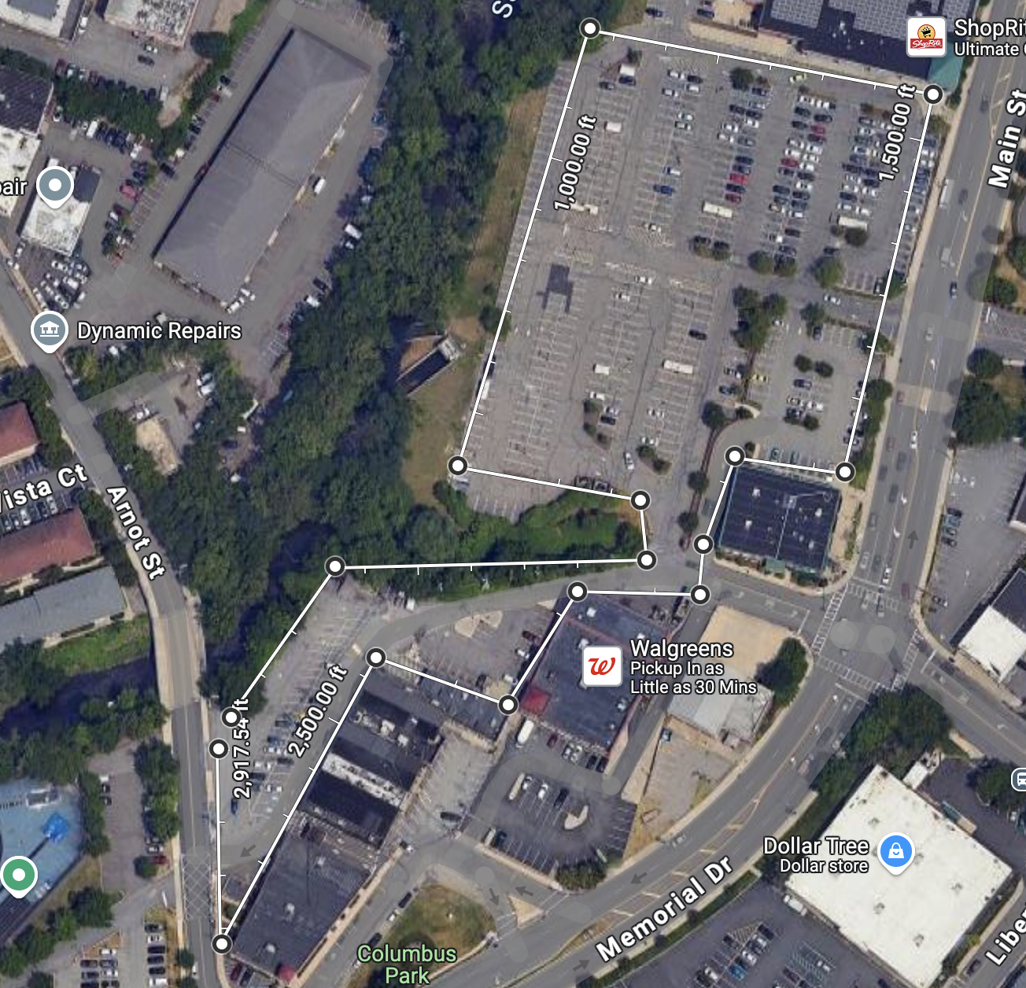

*Note*. strategic parking lot found in flood zone areas and its measurement.

To ensure an effective strategy, we first acquired a flood map of Lodi to identify and calculate the square footage of the affected zone (27,878,400sqft) (https://www.njfloodmapper.org/). Using tools like Google Maps, we evaluated specific sites that met the conditions necessary for porous asphalt to perform at peak efficiency. One key requirement was selecting low-traffic areas, as heavy vehicle use, such as trucks, can diminish the lifespan and functionality of porous asphalt (Rhode Island Department of Environmental Management, n.d.).

Through this process, we identified 14 strategic locations—12 parking lots, one park, and a low-traffic street located at the base of a hill. This particular street was a priority, as it not only experienced runoff from uphill asphalt-covered streets but also contributed stormwater directly to the Saddle River, exacerbating flooding in nearby residential areas. Installing porous asphalt here would help reduce runoff into the river and prevent stormwater from reaching residential zones.

The total area covered by these 14 locations amounted to 3,089,745.25 square feet, accounting for 10% of the total flood-affected area. To calculate the cost of implementing porous asphalt, we factored in both the removal of existing asphalt—estimated at $1 to $3 per square foot—and the installation of porous asphalt, which ranges from $7 to $13 per square foot (HomeGuide, n.d.-b). Combining these costs, the average expense was approximately $12 per square foot, bringing the total project cost to $37,076,943.00.

To assess the potential impact of this 10% coverage, we analyzed flood data from the past 10 years. Over this period, the total flood volume in Lodi was calculated at approximately 1,025,925,120 cubic feet (U.S. Geological Survey, 2024), with damages amounting to $18,371,865,600 based on FEMA’s flood cost estimates: $5 per square foot for minor floods, $10 for moderate floods, and $25 for major floods (Federal Emergency Management Agency [FEMA], 2019).

With porous asphalt capable of infiltrating approximately 75% of rainfall, the proposed 10% coverage of flood-affected areas could manage 85,276,968.9 cubic feet of water (Lee et al., 2023). This reduction in flood volume would save Lodi an estimated $1,534,985,440 in damages over 10 years, given the average cost per cubic foot ($18 per cubic foot), calculated as the total cost of $18,371,865,600 divided by the total flood volume of 1,025,925,120 cubic feet. This cost-saving figure more than covers the initial installation costs. Additionally, this strategic investment would not only mitigate flooding but also improve the town’s resilience to future storms, creating long-term economic and environmental benefits.

Community engagement and financial contributions also play a key role in supporting this project. Data from our survey suggest that a portion of Lodi’s population is willing to contribute to flood mitigation efforts. Approximately 51.85% of households expressed willingness to pay for installing permeable pavement, and of those, 78.26% indicated they would pay up to $100 annually. Applying these percentages to Lodi’s residential population of 9,280 households (Data USA, n.d.), annual contributions could total $370,388, covering 48% of the annual maintenance cost, estimated at $772,436 per year based on an average cost of $0.25 per square foot (HomeGuide, n.d.-a). These figures align with industry standards but can vary depending on factors such as local labor rates, climate conditions, and specific maintenance needs.

**Figure 4**

*Flood and installation Costs Excel analysis*

**4.1**  
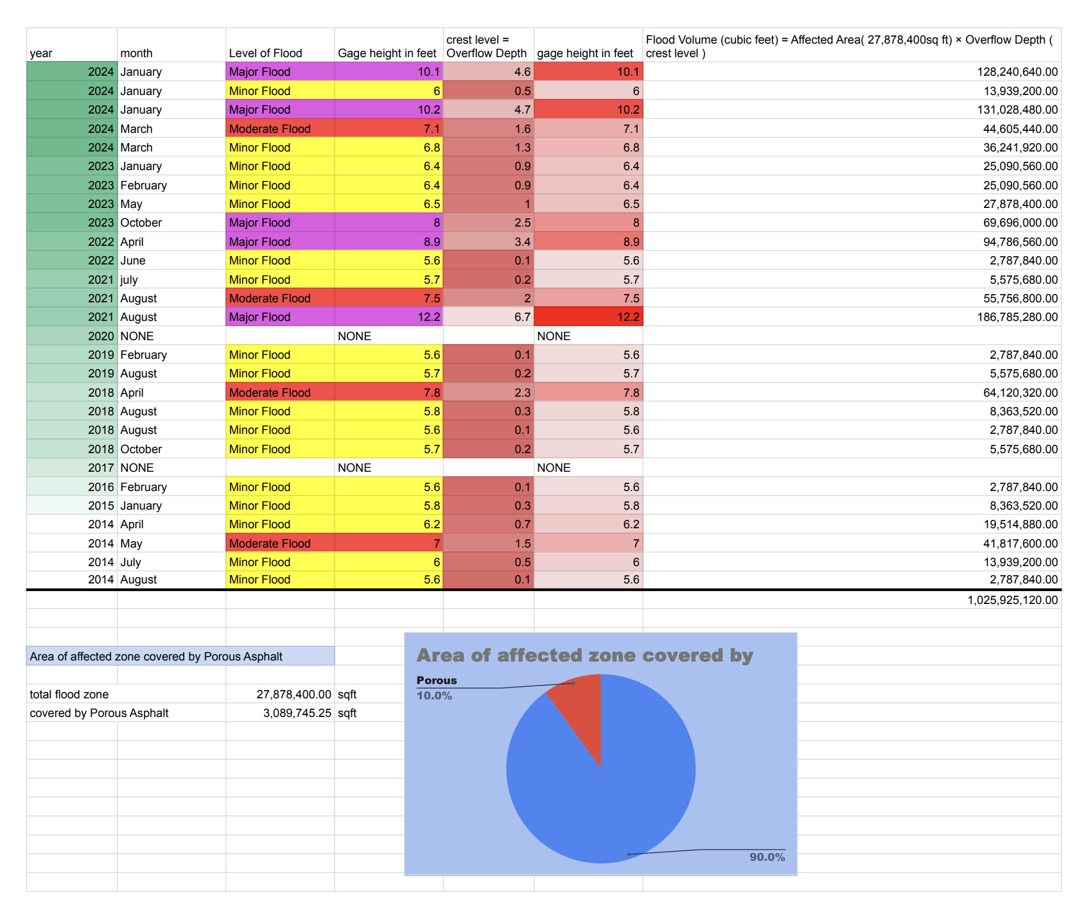

**4.2**  
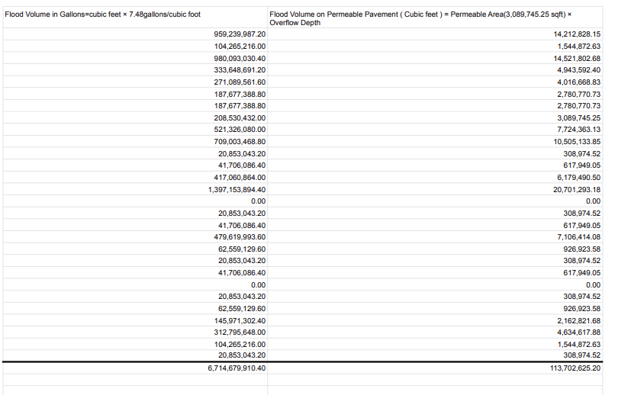

**4.3**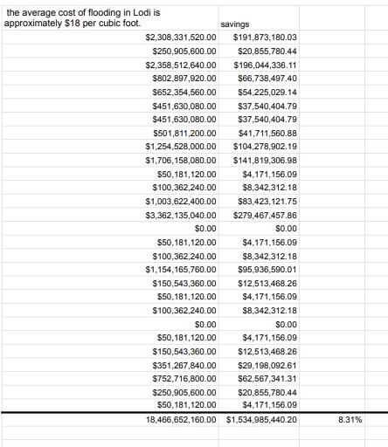

**

Note. *Locations can be found in appendix B*

**6. Implications**

The findings of this study reveal significant economic and environmental implications for flood prevention strategies in Lodi, New Jersey. Implementing permeable pavement in 10% of the flood-affected areas has the potential to save the community approximately $1.5 billion over a ten-year period. This figure is particularly notable when compared to the town's historical flooding expenses, which exceeded $18 billion in damages over the past decade. These findings emphasize the long-term financial benefits and practical viability of sustainable infrastructure solutions like porous asphalt.

The study also highlights the moderate level of community support for this initiative. The survey results indicate that 51.85% of families are willing to contribute financially to the installation of permeable pavement, with 78.26% prepared to pay up to $100 annually. On average, homeowners expressed a willingness to contribute $78.26 per year, reflecting an encouraging baseline of public support. However, this amount would cover only 48% of the estimated annual maintenance costs of permeable pavement. To bridge this gap, it is crucial to explore supplementary funding sources, such as municipal budgets, state and federal grants, and public-private partnerships.

Key trends emerged regarding the factors influencing willingness to pay. Families with recent flood experiences demonstrated a significantly higher likelihood of contributing financially, with 68.75% of these households expressing support compared to those without direct flood impacts. Meanwhile, only 21.82% of higher-income households were willing to pay, pointing to the need for targeted outreach efforts. Addressing these disparities requires focused communication strategies that emphasize the tangible benefits of permeable pavement—such as reduced property damage, increased infrastructure resilience, and enhanced community safety—to engage all socioeconomic groups effectively.

An important barrier identified was the community's need for information and confidence in the proposed solution. A majority of respondents (91%) indicated that access to comprehensive cost-benefit analyses and success stories from other cities would be essential to gain their support. These findings underscore the importance of transparent communication, evidence-based planning, and pilot projects to demonstrate the effectiveness of permeable pavement in flood-prone areas. By providing measurable results and fostering trust, policymakers can engage undecided respondents (33.32%) and strengthen public participation in flood mitigation initiatives.

**7. Conclusion**

Over all this study provides evidence that by prioritizing the most vulnerable areas, Lodi has the opportunity to showcase how green infrastructure, such as permeable pavement, can efficiently manage stormwater, reduce flood damages, and improve residents' quality of life. Implementing permeable pavement represents a forward-thinking and cost-effective solution to Lodi’s ongoing flooding challenges. While the survey results reflect encouraging community support, additional efforts to close information gaps, secure alternative funding, and engage hesitant or higher-income households will be essential to ensuring the project’s success. This initiative not only highlights the environmental and economic value of sustainable infrastructure but also demonstrates how collaboration and strategic investments can pave the way for a more resilient and sustainable future.

**References**

Arora, M., Chopra, I., Nguyen, M.H., Fernando, P., Burns, M.J. & Fletcher, T.D. (2023). Flood Mitigation Performance of Permeable Pavements in an Urbanised Catchment in Melbourne, Australia (Elizabeth Street Catchment): Case Study. *Water, 15*, 562. https:// doi.org/10.3390/w15030562

Data USA. (n.d.). *Lodi, NJ* profile. Retrieved December 14, 2024, from https://datausa.io/profile/geo/lodi-nj

Federal Emergency Management Agency. (2019, July). *Flood loss potential*. Retrieved December 14, 2024, from https://www.floodsmart.gov/sites/default/files/flood-loss-potential_jul19.pdf

HomeGuide. (n.d.). *Permeable pavers cost*. Retrieved December 14, 2024, from https://homeguide.com/costs/permeable-pavers-cost#:~:text=Permeable%20pavements%20cost%20%244%20to,%243%2C000%20to%20%249%2C000%20per%20space

HomeGuide. (n.d.). *Asphalt prices*. Retrieved December 14, 2024, from https://homeguide.com/costs/asphalt-prices

HomeGuide. (n.d.). *Permeable pavers cost*. Retrieved December 14, 2024, from https://homeguide.com/costs/permeable-pavers-cost

Hoppe, H.L. & Watson, K.M. (2012). USGS. *Flood-Inundation Maps for the Saddle River from Rochelle Park to Lodi, New Jersey, 2012.* https://pubs.usgs.gov/sim/3221/downloads/pdf/sim3221-pamphlet.pdf

Lee, Y.T., Ho, M.C., Chiou, Y.S., & Huang, L.L. (2023). Assessing the Performance of Permeable Pavement in Mitigating Flooding in Urban Areas. *Water, 15*(20), 3551. https://doi.org/10.3390/w15203551

Lodi Memorial Library. (n.d.). *History of Lodi*. https://www.lodilibrarynj.org/historical-photos-of-lodi.html

New Jersey Department of Health. (October, 2022). *Community Data Summary: LODI BORO*. https://nj.gov/health/hcpnj/documents/county-reports/Summaryreportonly/BERGEN_LODI%20BORO_Summaryreport.pdf

NJ Flood Mapper. (n.d.). *NJ flood mapper*. Retrieved December 14, 2024, from https://www.njfloodmapper.org/

Park, H.J., Song, S.M., Kim, D.H., & Lee, S.O. (September, 2024). Socioeconomic Impact on Urban Resilience against Flood Damage. *Applied Sciences 14*, 7882. https://doi.org/10.3390/app14177882

Reid, A. (March, 2024). Saddle River crests and ices over parts of Lodi, as residents in flood zone grow increasingly frustrated. *CBS News*. https://www.cbsnews.com/newyork/news/lodi-new-jersey-flooding-storm-saddle-river/

Rhode Island Department of Environmental Management. (n.d.). *Porous pavement: What is it? How does it work?*. Retrieved December 14, 2024, from https://dem.ri.gov/sites/g/files/xkgbur861/files/ri-stormwater-solutions/documents/factsheet_porous.compressed.pdf

Singer, M.N.; Hamouda, M.A.; El-Hassan, H.; Hinge, G. (2022). Permeable Pavement Systems for Effective Management of Stormwater Quantity and Quality: A Bibliometric Analysis and Highlights of Recent Advancements. *Sustainability, 14*,13061. https://doi.org/10.3390/ su142013061

State of Rhode Island, Department of Environmental Management. (2018). *Porous asphalt: For parking lots, light-traffic roads, and more*. https://dem.ri.gov/sites/g/files/xkgbur861/files/ri-stormwater-solutions/documents/factsheet_porous.compressed.pdf

Taitt, P. (January, 2024). Lodi streets flood as Saddle River crests, some residents evacuate. *ABC 7 New York*. https://abc7ny.com/flooding-lodi-new-jersey-evacuations/14306064/

U.S. Census Bureau (2022). *Lodi borough, Bergen County, NJ*. https://censusreporter.org/profiles/06000US3400341100-lodi-borough-bergen-county-nj/

U.S. Census Bureau. (2023). *U.S. Census Bureau quickfacts: United States*. https://www.census.gov/quickfacts/fact/table/us/pst045219

U.S. Geological Survey. (2011, October). *Summary of flooding in New Jersey caused by Hurricane Irene, August 27–30, 2011: U.S. Geological Survey* https://www.usgs.gov/news/summary-flooding-new-jersey-caused-hurricane-irene-august-27-30-2011

U.S. Geological Survey. (2024, December). *Saddle River at Lodi NJ - 01391500, Gage height, feet.* https://waterdata.usgs.gov/monitoring-location/01391500/#dataTypeId=continuous-00065-0&period=P365D&showMedian=false

Zhang, Z., Sha, A., Liu, X., Luan, B., Gao, J., Jiang, W., & Ma, F. (2020). State-of-the-art of porous asphalt pavement: Experience and considerations of mixture design. *Construction and Building Materials, 262*, 119998. https://doi.org/10.1016/j.conbuildmat.2020.119998